5. To go on a summer trip, Sam borrows $800. He makes no payments until the end of 6 years when he pays off the entire loan. The lender charges simple interest at an annual rate of 4%.
How much total interest will Sam have to pay?
I = A - P = $192.00
What will the total repayment amount be?
A = P(1 + rt)
A = 800(1 + (0.04 × 6)) = 992
A = $992.00

6. An amount of $19,000 is borrowed for 7 years at 5.5% interest, compounded annually. If the loan is paid in full at the end of that period, how much must be paid back? Round your answer to the nearest dollar.
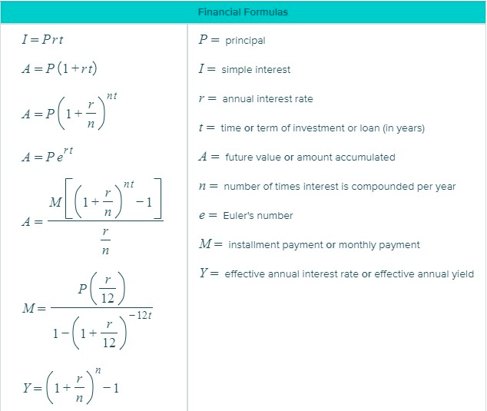
A = P(1 + r/n)^{nt}
A = 19,000.00(1 + 0.055/1)⁽¹⁾⁽⁷⁾
A = 19,000.00(1 + 0.055)⁽⁷⁾
A = $27,638.90

7. For the fourth week of December, Alice Cook worked 54.50 hours. Alice earns $12.50 an hour. Her employer pays overtime for all hours worked in excess of 40 hours per week and pays 1.5 times the hourly rate for overtime hours.
Calculate the following for the fourth week of December (round your responses to the nearest cent if necessary):
Regular pay amount: Regular pay rate x 40 hours = $12.50x40=$500
Overtime pay: Regular pay rate x 1.5 x 14.2 hours=$12.50x1.5x14.2=$266.25
Gross pay: Total pay for the week=$500+$266.25=$766.25
8. A chemical supply company pays their technician a $1150 monthly salary plus 6% commission on merchandise he sells each month. Assume Frank's sales were $30,500 for last month.
Calculate the following amounts:
Amount of Commission: Commission = Sales * commission % =$30,500*0.06=$1830
Gross Pay: Monthly Salary + Commission=$1150+$1830=$2980

9. The Watsons are saving up to go on a family vacation in 3 years. They invest $2500 into an account with an annual interest rate of 1.28% compounded monthly. Assuming no withdrawals are made, how much money is in the Watsons' account after 3 years?
Do not round any intermediate computations, and round your final answers to the nearest cent.
A = P(1 + r/n)^{nt}
A = 2,500.00(1 + 0.0128/12)⁽¹²⁾⁽⁷⁾
A = 2,500.00(1 + 0.001066667)⁽⁸⁴⁾
A = $2,734.21
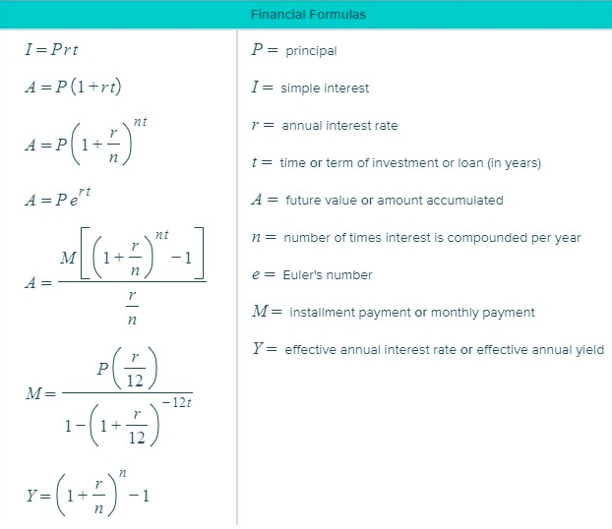

10. Latoya wants to save money to buy a motorcycle. She invests in an ordinary annuity that earns 6.6% interest, compounded monthly. Payments will be made at the end of each month.
How much money will she need to pay into the annuity each month for the annuity to have a total value of $5000 after 3 years?
Do not round intermediate computations, and round your final answer to the nearest cent.

P = A / (1 + r/n)^{nt}
P = 5,000.00 / (1 + 0.066/12)⁽¹²⁾⁽³⁾
P = 5,000.00 / (1 + 0.0055)⁽³⁶⁾
P = $4,104.08

11. Maria invested $4400 in an account that pays an annual interest rate of 3.6%, compounded quarterly. Find the amount in the account after one year, assuming no withdrawals are made. Do not round any intermediate computations, and round your answer to the nearest cent.

A = P(1 + r/n)^{nt}
A = 4,400.00(1 + 0.036/4)⁽⁴⁾⁽¹⁾
A = 4,400.00(1 + 0.009)⁽⁴⁾
A = $4,560.55

13. To help open up a restaurant, Alan borrowed money from a bank.
He took out a personal, amortized loan for $47,500, at an interest rate of 6.5%, with monthly payments for a term of 8 years.
(a) Find Alan's monthly payment --> $611.75
(b) If Alan pays the monthly payment each month for the full term, find his total amount to repay the loan $58,728.08
(c) If Alan pays the monthly payment each month for the full term, find the total amount of interest he will pay. --> $13,028.08

17. A drawer is filled with 7 black shirts, 5 white shirts, and 10 gray shirts.
One shirt is chosen at random from the drawer. Find the probability that it is not a gray shirt.
Total shirts = 7+5+10 = 22
The probability to chosen gray shirt = 10/22=0.45
The probability that it is not a gray shirt =1-0.45 =0.55

Write your answer as a reduced fraction.
22. A panel for a political forum is made up of 14 people from three parties, all seated in a row. The panel consists of 1 Labour Party member, 6 Independents, and 7 Republicans. In how many distinct orders can they be seated if two people of the same party are considered identical (not distinct)?
The required number of distinct ways to be seated is = 14!/(1!*6!*7!) =24024

29. Fran the Fearless has a well-known act at a local zoo. As part of the act, Fran handles a scary animal that she picks at random out of the Box of Terror. The following animals are in the box: 14 poisonous snakes, 2 nonpoisonous snakes, 8 poisonous spiders, and 7 nonpoisonous spiders. What is the probability that the animal Fran picks is nonpoisonous or is a spider?
Provide two reasons why we would want to sample a subset of values from a popultion rather than observe
5.66 The prisoner’s dilemma, cross-cultural research, and hypothesis testing
Do not round intermediate computations, and round your answer to the nearest hundredth.
Poisonous snakes = 14
Nonpoisonous snakes = 2
Poisonous spiders = 8
Nonpoisonous spiders = 7
We need to find P(poisonous or snake )
Total animals = 10+5+8+6 = 29
poisonous = poisonous snake + poisonous spiders = 10 + 8 = 18
snakes = 10+5 = 15
Using addition rule of probability :
P( A or B) = P( A ) + P( B ) - P ( A and B )
so P( poisonous or snake ) = P(poisonous) + P( snake ) - P( poisonous snake )
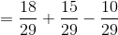
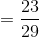
P( poisonous or snake ) = 0.79
Therefore the probability that the animal Fran picks is poisonous or is a snake is 0.79
30. At a local college, 91 of the male students are smokers and 819 are non-smokers. Of the female students, 160 are smokers and 640 are non-smokers. A male student and a female student from the college are randomly selected for a survey. What is the probability that both are smokers?

The probability of male students who are smokers
The probability of female students who are smokers
The probability of both are smokers

31. A university class has 22 students: 6 are art majors, 4 are history majors, and 12 are business majors. The professor is planning to select two of the students for a demonstration. The first student will be selected at random, and then the second student will be selected at random from the remaining students. What is the probability that two business majors will be selected?
Do not round your intermediate computations. Round your final answer to three decimal places.
Total student =22
Art majors = 6
History majors = 4
Business majors = 12
The probability of first student selected at random business majors
The probability of second student selected at random business majors

The probability that two business majors will be selected = 0.55*0.57 = 0.3135

32. An urn contains 7 pink and 5 green balls. Six balls are randomly drawn from the urn in succession, with replacement. That is, after each draw, the selected ball is returned to the urn. What is the probability that all 6 balls drawn from the urn are pink? Round your answer to three decimal places.

The probability of drawing a black is the same for each draw
P(pink) = 7/12
Thus P(6 black) = (7/12)^6 = 0.039

33. A survey showed that 24% of college students read internet news on a regular basis and that 83% of college students regularly watch the news on TV. The survey also showed that 20% of college students both follow TV news regularly and read internet news regularly.
What is the probability that a randomly selected college student reads internet news regularly, given that he or she watches TV news regularly? Round your answer to the nearest hundredth.
a)
P(read newspaper regularly |watches TV news regularly) =P(both)/P(watches TV news regularly)
=0.20/0.83
=0.24
b)
P(|watches TV news regularly |read newspaper regularly | =0.20/0.24 =0.83

37. There were 21 participants in a recent study on personality traits. After being shown five images, 1, 2, 3, 4 and 5, each participant selected the one that was most appealing to them.
Image
2 | 4 | 3 | 5 | 4 | 1 | 3
1 | 1 | 2 | 1 | 4 | 5 | 5
4 | 2 | 5 | 4 | 2 | 3 | 1

Complete the frequency table.
a)

Image | Frequency
1 | 5
2 | 4
3 | 3
4 | 5
5 | 4

38. In late August of last year, Pie Dee Restaurant sponsored its first pizza-eating contest. For the contest, the number of slices of cheese pizza eaten by each contestant was counted. The histogram below summarizes the data. Use the histogram to answer each of the questions.
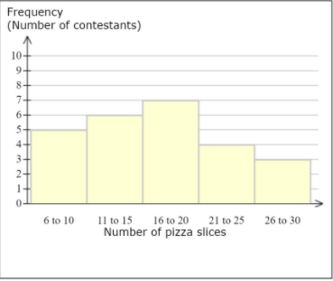
(a) One class is the most frequent. How many contestants are in this class?
(b) How many contestants ate 15 or fewer pizza slices?
(c) What is the class width?

a. 7 contestants ate from 16 to 20.
b. 5+6=11 contestants. ate 15or fewer pizzas.
c. Class width = 4

39. It seems these days that students have to work more and more each week to be able to afford the costs of college. For a recent labor survey conducted by the government, there were 75 respondents who were working while attending college. The frequency distribution below summarizes the number of hours worked per week as reported by the respondents.
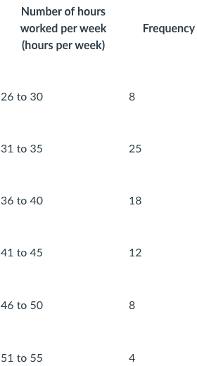
Based on the frequency distribution, using the midpoint of each data class, estimate the mean number of hours worked per week by the respondents. For your intermediate computations, use four or more decimal places, and round your answer to one decimal place.

To estimate the mean we need to follow the below mentioned steps.
First we need to multiply the midpoints of the classes with their respective frequencies and add the results
= (28*8) + (33*25)....
= 3017
Now we need to divide this sum by number of frequencies
Mean = 3017/(8+25...) = 38.2

44. The score on a standardized test for a certain year is modeled using the normal distribution shown below.
The mean of the distribution is 72.7 points and the standard deviation is 5.4 points.
In the figure, V is a number along the axis and is under the highest part of the curve. And, U and W are numbers along the axis that are each the same distance away from V.
Use the empirical rule to choose the best value for the percentage of the area under the curve that is shaded, and find the values of
U, V, and W.
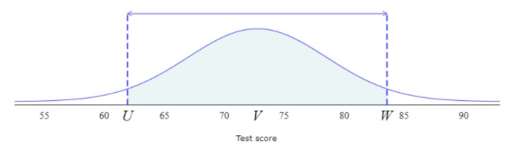
Percentage of total shaded area:
U =
V =
W =
Given that the score of a standardized distribution is modeled using the Normal Distribution.
The mean is given as 72.7, and the standard deviation is 5.4
Here in the figure, V is the highest part of the curve. U and W are the number which are same distance away from V
Now, since the distribution is normal, so it is symmetric and therefore, mean = median = mode
Since, mean is given as 72.7, so mode will also become 72.7
Hence, the value of V is 72.7
As, U and W are placed at an equal distance apart from V, so we can write
W-V = V-U
=> W + U = 145.4 --------------------------------------- (i)
Let us assume,
Then,
The value of U and W are obtained as,
and
Therefore, --------------------------- (ii)
Since, the equation (i) and equation (ii) becomes same. So, the value of U and W are obtained as 83.5 and 61.9 respectively.
Now, the area of the shaded region can be obtained as,
Hence, the percentage of area under the curve is obtained as 95.4%

